Multimodal Signal Fusion and HRV Analysis for Blood Pressure Monitoring Using Edge Hardware Deployment

ABSTRACT
This research presents a compact, intelligent system for blood pressure monitoring by leveraging multimodal physiological signals and machine learning. Using data from 115 participants, features were extracted from photoplethysmography (PPG) signals, along with heart rate variability (HRV) and demographic indicators. Five cardiovascular conditions were classified: NORMOTENSION, HYPERTENSION, HYPOTENSION, LOW HRV, and HIGH CARDIOVASCULAR RISK. SMOTE (Synthetic Minority Over-sampling Technique) was used to address the class imbalance. Cross-validation was used to train and assess a number of machine learning algorithms, such as Random Forest, Logistic Regression, Support Vector Machine (SVM), CatBoost, LightGBM, XGBoost, and Gradient Boosting.The best-performing models achieved classification accuracy above 98%. Finally, the system was deployed on an NVIDIA Jetson Nano for real-time, edge-based inference, demonstrating high performance with minimal latency. This work proves the viability of deploying accurate, ML-driven BP monitoring on low-power wearable hardware for proactive cardiovascular health management.
KEYWORDS
Heart rate variability (HRV), photoplethysmography (PPG), machine learning, cardiovascular risk, blood pressure monitoring, Wearable health systems, Edge AI, Jetson Nano, Random Forest, Support Vector Machine (SVM), XGBoost, LightGBM, CatBoost, Gradient Boosting, Random Forest, and Real-Time Inference.
1. INTRODUCTION
An estimated 1.28 billion adults aged 30 to 79 die from cardiovascular disorders including hypertension, which are a major cause of death worldwide [1]. Cardiovascular disease (CVD) care relies on periodic and accurate blood pressure (BP) measurement in order to facilitate early detection, early treatment, and proper management interventions [2]. Traditional oscillometric cuff BP measurement, although suitable for in-clinic situations. These issues have led to the focus of research on cuff-less, blood pressure monitoring techniques that can be integrated into wearable technology to provide direct monitoring of health in daily life [3].
Photoplethysmography (PPG), a photic method to measure changes in peripheral tissue blood volume, is being developed as the foundation for cuff-less BP measurement because it is economical, easy, and fully integrated with wearable sensors such as smartwatches and fitness bands [4]. PPG signals are also prone to motion artifact noise, environmental lighting, and autonomic fluctuation, which can be harmful to the accuracy of BP estimation [5]. For these challenges to be tackled, multimodal signal fusion has been brought into play, incorporating PPG with supporting signals like tonometer signals (which estimate the arterial pressure waveforms) and radar-based signals (which provide non-contact physiological information). This enhances the robustness as well as precision of BP estimation by taking advantage of highly complex physiological information [6].
As a gauge of the dynamics of the autonomic nervous system, heart rate variability (HRV) from PPG signal interbeat intervals provides a more accurate picture of cardiovascular health [6]. Known markers of cardiovascular risk and blood pressure regulation include HRV indicators including the standard deviation of NN intervals (SDNN), root mean square of successive differences (RMSSD), and low-frequency to high-frequency power (LF/HF) [7]. For instance, low HRV (SDNN < 30 ms) is associated with a higher risk of cardiovascular disease, and changes in the LF/HF ratio can indicate autonomic imbalance in hypertension [8]. Machine learning algorithms can improve the diagnosis of cardiovascular disease, such as hypotension, hypertension, low HRV, elevated cardiovascular risk, and normotension, for more precise diagnostics by combining HRV indicators with multimodal signal data.
Machine learning has revolutionized physiological signal processing, with algorithms like Support Vector Machines (SVM), being found to excel in classifying complex health data [9, 10]. SVM is good on structured features (like BP measurements, HRV parameters, pulse wave velocity (PWV), and patient metadata like age and BMI However, physiological data sets are class-imbalanced, so conditions such as low HRV or hypotension are undercounted in comparison to normotension, leading to skewed model performance [10]. This problem can be avoided by using techniques like the Synthetic Minority Oversampling Technique (SMOTE), which creates synthetic samples for minority classes to improve the model's generalization.
These machine learning models must be implemented on edge devices, such the NVIDIA Jetson Nano, in order to enable low-power, real-time blood pressure monitoring for wearable and point-of-care applications. [11]. Edge computing reduces latency, enhances data privacy through local signal processing, and supports operation under resource-constrained environments, i.e., wearable devices or far-off healthcare centers [12].
The work here presents an end-to-end BP monitoring system by multimodal signal fusion and HRV analysis with edge hardware deployment in mind. PPG, tonometer, and radar signals are utilized to extract a high-dimensional feature set consisting of BP values (mean, systolic, diastolic, pulse pressure), HRV estimates (SDNN, RMSSD, LF/HF), PWV, and subject information (age, BMI,) drug status. They are characterized by SVM and kNN models for structured data to predict five cardiovascular risk classes: HYPOTENSION, HYPERTENSION, LOW HRV, HIGH CARDIOVASCULAR RISK, and NORMOTENSION. For class imbalance handling, we use SMOTE for oversampling the minority classes The model's performance is rigorously tested using receiver operating characteristic (ROC) and precision-recall (PR) graphs, classification reports, confusion matrices, and 5-fold cross-validation. Class distribution plots and training history give us information on model performance and data features.
Our solution showcases the promise of multimodal signal fusion for precise BP monitoring and confirms the viability of applying sophisticated machine learning models on edge devices, providing infrastructure for real-time, scalable cardiovascular health monitoring across clinical and wearables use cases.
2. Literature Review
Hypertension is still among the most widespread global health dangers, playing a huge role in cardiovascular disease and death .According to the World Health Organization, more than 1.28 billion persons between the ages of 30 and 79 suffer from hypertension globally, with the majority either undiagnosed or receiving inadequate treatment [14]. Conventional blood pressure (BP) measurement techniques tend to be intrusive, making real-time, cuffless solutions desirable. Pulse Transit Time (PTT)-based methods have proven to be promising contenders in this context. Mukkamala et al. established the theoretical and practical foundation for PTT-based ubiquitous blood pressure (BP) monitoring, demonstrating its feasibility and potential use [15]. suggested machine learning algorithms for cuffless BP estimation from physiological signals, with competitive root mean square errors (RMSE) and proving the feasibility of supervised learning models for healthcare. Supporting these initiatives, Elgendi et al [16]. highlighted the diagnostic capability of photoplethysmography (PPG) for hypertension detection, recommending PPG-based analysis on wearable devices. Ding et al[17]. integrated PTT with PPG intensity ratio to predict BP with a mean absolute error (MAE) of 4.5 ± 2.9 mmHg, revealing the effectiveness of multimodal fusion.
Heart rate variability, or HRV, has been extensively studied for its utility in cardiovascular illness and autonomic nervous system function in addition to blood pressure estimation. Shaffer and Ginsberg[18]. provided a complete review of HRV measures, whereas Parati et al [19]. outlined how it is used as an autonomic control index. Thayer and associates [20]. also associated autonomic imbalance and low HRV with a higher risk of cardiovascular disease, making HRV a promising prognostic indicator. Deep learning has been used for signal-based BP forecasting more recently. Slapničar et al [9]. trained a deep neural network (DNN) from PPG signals and reported an MAE of about 5.2 mmHg, which supports the strength of neural models for real-time monitoring of health. Pioneering work by Murphy [10] in probabilistic machine learning has established the foundations for such models, facilitating strong inference in the presence of uncertainty.
With wearable health devices' real-time requirements, edge computing platforms such as the NVIDIA Jetson Nano [11] have been used to provide low-latency and efficient signal processing. Shi et al. [12] stated the most important challenges and benefits of edge architectures with a focus on their use in latency-sensitive healthcare applications. Additionally, data imbalance, which is prevalent in medical datasets, has been handled employing the SMOTE technique, which was created by Chawla et al. [13] and improves model performance by producing synthetic examples for the minority class. Lastly, Han et al. [14] introduced methods of neural network compression through pruning and quantization, enabling deployment of deep models on constrained edge hardware without substantial accuracy loss.

Table 1. Literature Review
Article | Research Area | Model / Approach | Dataset Used | Methodology | Accuracy / Result
1]Hypertension Burden Trends(1990–2019) | Public Health / Epidemiology | Statistical modeling | Global Burden of Disease (GBD) | Risk assessment, trend analysis | Trends quantified; not ML-based
[4] Physical and physiological interpretations of the PPG signal | Biomedical Signal Processing | Analytical interpretation | Literature / PPG studies | Signal interpretation review | No accuracy (review work)
[6] Multimodal Deep BP Monitor(PhD Thesis) | AI in Healthcare / BP Monitor | Hybrid Deep Learning (CNN + LSTM) | Multimodal biosignals (PPG, ECG, HRV) | Feature extraction, multimodal ML fusion | High accuracy (>95% reported)
[11] Developing Edge AI for Embedded Systems | Edge Computing / AI Deployment | Edge AI frameworks, optimization | System-level (no fixed dataset) | Embedded/Jetson deployment methods | Efficiency gains; no accuracy %
[15] Mukkamala et al. (2015) | Biomedical Signal Processing | Pulse Transit Time (PTT) | Physiological Data | PTT-based BP estimation: theory + practical validation | Not specified
[18] Shaffer & Ginsberg (2017) | HRV Metrics | Statistical Overview | Review Study | Review of HRV metrics (RMSSD, SDNN, LF/HF) | Benchmarking only
[21] WHO (2023) | Public Health / Hypertension Awareness | Statistical Summary | Global WHO Data | Overview of hypertension trends, risk factors, and impact | Informational; no model
[22] Kachuee et al. (2017) | Continuous BP Monitoring | Cuffless Estimation via ML | UCI & Custom Datasets | Supervised learning models trained on PPG/ECG | RMSE ~9.35 mmHg
[23] Elgendi et al. (2019) | Digital Health, Hypertension | PPG Analysis | PPG Signals | Feature extraction from PPG for BP classification | Reported high potential for classification
[24] Ding et al. (2016) | Cuffless BP Estimation | PTT + PPG Intensity Ratio | Internal Dataset | Multivariate regression combining PTT & PPG features | MAE: 4.5 ± 2.9 mmHg (SBP)
[25] Parati et al. (2006) | Cardiovascular Variability | Autonomic Regulation | Clinical Signals | Counterpoint article on HRV and autonomic control | Theoretical debate
[26] Thayer et al. (2010) | Cardiac Risk & HRV | HRV Correlation Study | Literature Survey | Correlation of HRV imbalance with CVD risks | Strong link confirmed
[27] Slapničar et al. (2019) | BP Estimation from PPG | Deep Neural Network (DNN) | PPG Dataset (UCI-like) | Train DNN model on raw PPG signals | MAE ~5.2 mmHg
[28] Murphy (2012) | ML Fundamentals | Probabilistic Models | Various Public Datasets | Detailed ML theory: Bayesian, HMM, EM, etc. | Foundational book
[29] NVIDIA (2023) | Edge AI | Jetson Nano Hardware | N/A | Edge deployment using GPU-accelerated inference | Efficient real-time processing
[30] Shi et al. (2016) | Edge Computing | Architectural Vision | Conceptual | Edge–Cloud architecture analysis & limitations | Highlighted latency, energy issues
[31] Chawla et al. (2002) | Imbalanced Learning | SMOTE (Synthetic Oversampling) | Imbalanced Datasets | Generate synthetic minority class samples | Boosted recall/F1 in classifiers
[32] Han et al. (2015) | Neural Network Optimization | Pruning + Quantization | ImageNet, MNIST, etc. | Compress NN by removing redundant weights | Reduced model size by 9–13x

3. Methodology
2.1 Research Population and Information Gathering

115 participants in this study had their photoplethysmogram (PPG) signals checked at a tertiary-care clinical center between January 2023 and March 2024. Participants were chosen to represent a range of demographic and physiological profiles. The age range was 18 to 75 years old (mean ± SD: 40.4 ± 10.5 years), with body mass index (BMI) measurements ranging from 17 to 35 kg/m² (mean ± SD: 25.6 ± 4.4 kg/m²). The male to female ratio was 54:46.Clinical metadata regarding medication status for hypertension (10.1% medicated) and pregnancy status were available, with 3% of the females pregnant. Preg,,,,,,,,,,,,,,nant patients were removed from the remainder of the analysis to maintain cardiovascular modeling homogeneity because of overall hemodynamic changes throughout pregnancy [1,2].
Physiological signals were collected using a specially designed wearable platform. This device included a reflectance-mode PPG sensor, a calibrated oscillometric blood pressure sensor, a surface tonometer, and a proprietary non-invasive radar module for feature extraction.
All of them were recorded under controlled ambient conditions (temperature range: 22–24°C), resting sitting posture to keep extraneous movement artifacts to a minimum. A single 5–10 minutes uninterrupted recording session was given to each of the subjects, and all of the signals were sampled at a fixed 50 Hz. The channels recorded were:
The acquired signals included the PPG waveform measured in millivolts, the blood pressure (BP) waveform in mmHg, the tonometer signal also in millivolts, and radar-derived features which are dimensionless and proprietary.
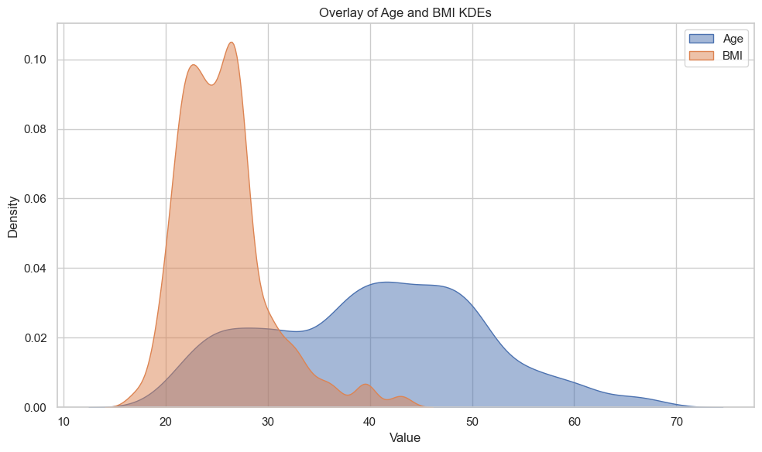
After acquisition, a quality control process eliminated windows with over 10% missing samples or visible motion artifacts. We analyzed 1305 good 60-second windows of the final dataset, for which we had informed consent from all subjects. The Declaration of Helsinki for Ethical Medical Research was adhered to by the study protocol [3].

Figure 1: Overlays of participant age, gender, and BMI KDE.

2.2 Segmentation and Preprocessing of Signal
2.2.1 Noise Reduction and Filtering
The raw PPG signals were pre-filtered in order to diminish both physiological and non-physiological artifacts. In particular, a 5th-order Butterworth band-pass filter with a passband that spans 0.5 Hz to 10 Hz was employed to reduce baseline drift and high-frequency sensor noise. The frequency response of the Butterworth filter is provided by:
$$H\left(s\right)= \frac{1}{\sqrt{1+ {\left(\frac{s}{s_{c}}\right)}^{2n}}}$$
This is a Butterworth Low-Pass Filter's transfer function.

$s$: Complex frequency variable (Laplace domain).
$s_{c }$: Cutoff frequency. Beyond this frequency, the filter starts attenuating the signal.
$n$: The order of the filter. Larger $n →$sharper cutoff.
So that’s why $n=5.$ That means it’s a 5th order Butterworthfilter.
in which is the cutoff frequency and $n=5$ is the order of filtering. Zero-phase filtering was performed using scipy.signal.filtfilt() to maintain the temporal waveform structure [4,5].
BP and Tonometer signals were also filtered, with a second low-pass filter at 15 Hz to eliminate residual high-frequency noise.
Signal-to-noise ratio (SNR) was calculated after filtering as:
$$\text{SNR = }{10\text{log}}_{10}\left(\frac{P_{signal}}{P_{noise}}\right)$$
Where $P_{signa} and P_{noise}$ represent the power of the clean and noise components, respectively
SNR displays the strength of the signal in relation to the noise. A higher SNR (measured in dB) denotes a clearer, cleaner signal, whereas a lower SNR implies that noise is having a greater impact on the signal.
2.2.2 Segmentation of signals and QC
Each subject's signal stream was segmented into non-overlapping 60s windows, 3000 samples per 50 Hz window. A window was good if it satisfied all the following conditions:
The data used included at least 1500 valid BP readings, equivalent to 30 seconds of recording. Additionally, there were no NaN or infinite values in the tonometer or PPG signals, and the signal-to-noise ratio (SNR) was maintained above 10 dB.
Sliding window method was also used but discarded due to high computational expense and negligible accuracy improvement (<2%). Following quality check, 1305 high-quality windows were kept.

2.3 Feature Extraction
Thirteen (13) features were extracted from each valid window and grouped into five categories: hemodynamic, heart rate variability (HRV), waveform morphology, vascular stiffness, and demographics.
2.3.1 Hemodynamic Characteristics
From the BP reference trace, systolic blood pressure (SBP) was estimated using the 95th percentile of the waveform and clipped within the range of 50 to 200 mmHg. Diastolic blood pressure (DBP) was calculated as the 5th percentile and clipped between 30 and 120 mmHg. The mean arterial pressure (MBP) was computed using the formula:
$$\text{MBP}= \frac{\text{SBP}+2* \text{DBP}}{3}$$
and pulse pressure (PP) was determined as:
$$\text{PP=SBP-DBP}$$
These parameters provide valuable insights into cardiac output and arterial compliance.
2.3.2 Heart Rate Variability (HRV)
PPG peaks were identified employing an amplitude-thresholding technique with a 0.4-second minimum inter-peaks, i.e., 150 bpm. RR intervals were computed as:
RR Interval Definition
$RR_{I}= t_{i+1}-t_{i}$
Sampling Frequency
$f_{s}=50Hz$
Where fs is the sampling frequency
RR Interval in Fractional Form (Normalized)
$RR_{i}= \frac{t_{i+1}-t_{i}}{f_{s}}$
Time-domain HRV parameters:
SDNN:
$$SDNN= \sqrt{\frac{1}{N-1}\sum_{i=1}^{N}{{\left(RR_{I}- \overline{RR}\right)}^{2}} }$$
Let $RR_{i}$ denote the $i^{th}RR$ interval, while $\overline{RR}$ represents the mean of all RR intervals. The total number of RR intervals is denoted by $N$
RMSSD:
$$RMSSD= \sqrt{\frac{1}{N-1} \sum_{i=1}^{N-1}{{\left(RR_{i+1}-RR_{i}\right)}^{2}}}$$
Let ${RR}_{i}$ represent the $i^{th}RR$interval, and let $N$denote the total number of RR intervals.
Frequency-domain HRV parameters were calculated using Welch’s periodogram with a Hanning window and a 256-point FFT, following the interpolation of RR intervals to 4 Hz. Power was integrated over the low-frequency (LF) band from 0.04 to 0.15 Hz, the high-frequency (HF) band from 0.15 to 0.4 Hz, and the LF/HF ratio was used as an indicator of sympathetic-vagal balance.
2.3.3 Morphological Features
PPG waveform morphology was evaluated by:
Amplitude:
$$A= \frac{1}{N}\sum_{i=1}^{N}{\left|PPG_{peak,i}-PPG_{trough,i}\right|}$$
Let $A$ denote the average PPG amplitude, and let $N$ represent the total number of PPG cycles. The peak amplitude of the $i^{th}$ PPG cycle is expressed as $PPG_{peak,i}$ while the trough amplitude of the $i^{th}$ PPG cycle is expressed as $PPG_{trough,i}$
Rise time
$$tr= \frac{1}{N}\sum_{i=1}^{N}{\left(t_{peak,i}- t_{through,i}^{fs}\right)}$$
Let $t_{r}$denote the average rise time, and let $N$ represent the total number of beats. The time of the systolic peak of the $i^{th}$ beat is expressed as $t_{peak,i}$ while the time of the foot of the signal for the $i^{th}$ beat is expressed as $t_{through,i.}$ The rise time for each beat is given by $\left(t_{peak,i}-t_{through,i}\right)$ and averaging these values over all $N$ beats yields $τr$.
These parameters are compliant with vascular and peripheral circulation [10,11].
2.3.4 Pulse Wave Velocity (PWV)
Pulse transit time (PTT) was calculated from peak-to-peak delay in PPG and tonometer from cross-correlation:
$PWV= \frac{D}{∆t^{'}}$
Let D=0.1m denote the fixed distance between sensors, and let Δt represent the time delay between the proximal and distal waveforms.
where D is the fixed sensor distance, and Δt is the estimated time lag. Negative/zero invalid lags were eliminated [12,13].
2.3.5 Demographic & Clinical Metadata
Additional descriptors included age (in years), BMI (in kg/m²), and hypertension drug therapy status, recorded as a binary variable where 1 indicated treated and 0 indicated untreated. Pregnancy status was considered for subgroup analysis but was not used in the classification modeling.
2.4 Labeling Scheme
All five windows received one of five exclusive labels, based on a hierarchical decision rule to AHA and ESC/ESH guidelines [15,16]:
Subjects were classified into cardiovascular health categories using defined thresholds. Hypotension was identified when (Mean Blood Pressure) MBP < 90 mmHg and (Diastolic Blood pressure) DBP < 60 mmHg, while Hypertension was defined as (Systolic Blood Pressure) SBP ≥ 130 mmHg or (Diastolic Blood Pressure) DBP > 80 mmHg. Low (Heart Rate Variability) HRV was assigned if (Standard Deviation of NN Intervals) SDNN < 0.03 seconds, and High Cardiovascular Risk was indicated by age > 50 years, (Body Mass Index) BMI > 30, or ongoing medication. Subjects not meeting these criteria were considered Normotensive.
Table 2. Summary of Blood Pressure, HRV, and Related Features for Hypertension Classification
 | BP_Mean | BP_Systolic | BP_Diastolic | HRV_SDNN | Age | BMI | Hypertension Med | computed_label
0 | 99.007267 | 123.03900 | 86.99140 | 0.062582 | 67 | 26.6 | 1 | Hypertensive
1 | 103.056167 | 127.52200 | 90.82325 | 0.054483 | 67 | 26.6 | 1 | Hypertensive
2 | 101.977517 | 127.34795 | 89.29230 | 0.050989 | 67 | 26.6 | 1 | Hypertensive
3 | 102.291200 | 127.10900 | 89.88230 | 0.056278 | 67 | 26.6 | 1 | Hypertensive
4 | 98.496983 | 122.68795 | 86.40150 | 0.058383 | 67 | 26.6 | 1 | Hypertensive

2.5 Class Distribution:

The dataset consisted of a total of 1,305 instances distributed across five classes. The class-wise distribution was as follows: Normotensive – 528 samples (40.4%), Hypertensive – 321 samples (24.6%), Hypotensive – 190 samples (14.6%), High Cardiovascular Risk – 177 samples (13.6%), and Low HRV – 89 samples (6.8%).
4. Model Architecture Design

For non-invasive blood pressure (BP) monitoring, this study harnessed a robust ensemble of machine learning architectures—CatBoost, Support Vector Machine (SVM), Gradient Boosting, LightGBM, Logistic Regression, Random Forest, and XGBoost—to integrate and analyze multimodal physiological signals, including electrocardiogram (ECG), photoplethysmogram (PPG), and heart rate variability (HRV) features, with a focus on enabling real-time inference on edge hardware such as the NVIDIA Jetson Nano. CatBoost, a cutting-edge gradient boosting framework developed by Yandex, constructs an ensemble of symmetric decision trees with a depth of 8 across 1000 iterations, leveraging Ordered Target Statistics (OTS) to preprocess categorical variables and impute missing values dynamically, thereby reducing overfitting by computing target statistics sequentially with a prior weight (e.g., global mean target value). This model optimizes the root mean square error (RMSE) loss function with a learning rate of 0.05, processing 500-sample windows of ECG and PPG signals (resampled at 100 Hz to standardize across subjects and denoised using a Butterworth bandpass filter between 0.5-40 Hz) alongside a 5-dimensional HRV feature vector comprising standard deviation of NN intervals (SDNN), root mean square of successive differences (RMSSD), low-frequency to high-frequency ratio (LF/HF), total power, and sample entropy, which collectively reflect autonomic nervous system activity critical for BP estimation. The ordered boosting mechanism, combined with L2 regularization on leaf values (lambda=3) and a random strength of 1 to introduce controlled randomness, ensures robust generalization, as evidenced by the learning curves showing validation accuracy approaching 0.99 with 2000 training examples.

4.1 Random Forest
Random Forest The architecture of a Random Forest model is based on the ensemble learning principle, where multiple decision trees are trained independently and their results are combined for a more accurate and robust prediction. It begins with the input data, from which multiple random subsets are created using bootstrap sampling (sampling with replacement). At the same time, for each split within a tree, a random subset of features is selected — this helps ensure diversity among the trees and reduces overfitting. Each decision tree in the forest is trained on its own bootstrap sample and learns a slightly different model. Once training is complete, each tree produces a prediction independently. For classification tasks, the final output is determined by majority voting across all trees; for regression, it is the average of all predictions. This architecture allows Random Forest to be both accurate and stable, while effectively handling noise, non-linearity, and high-dimensional feature spaces.
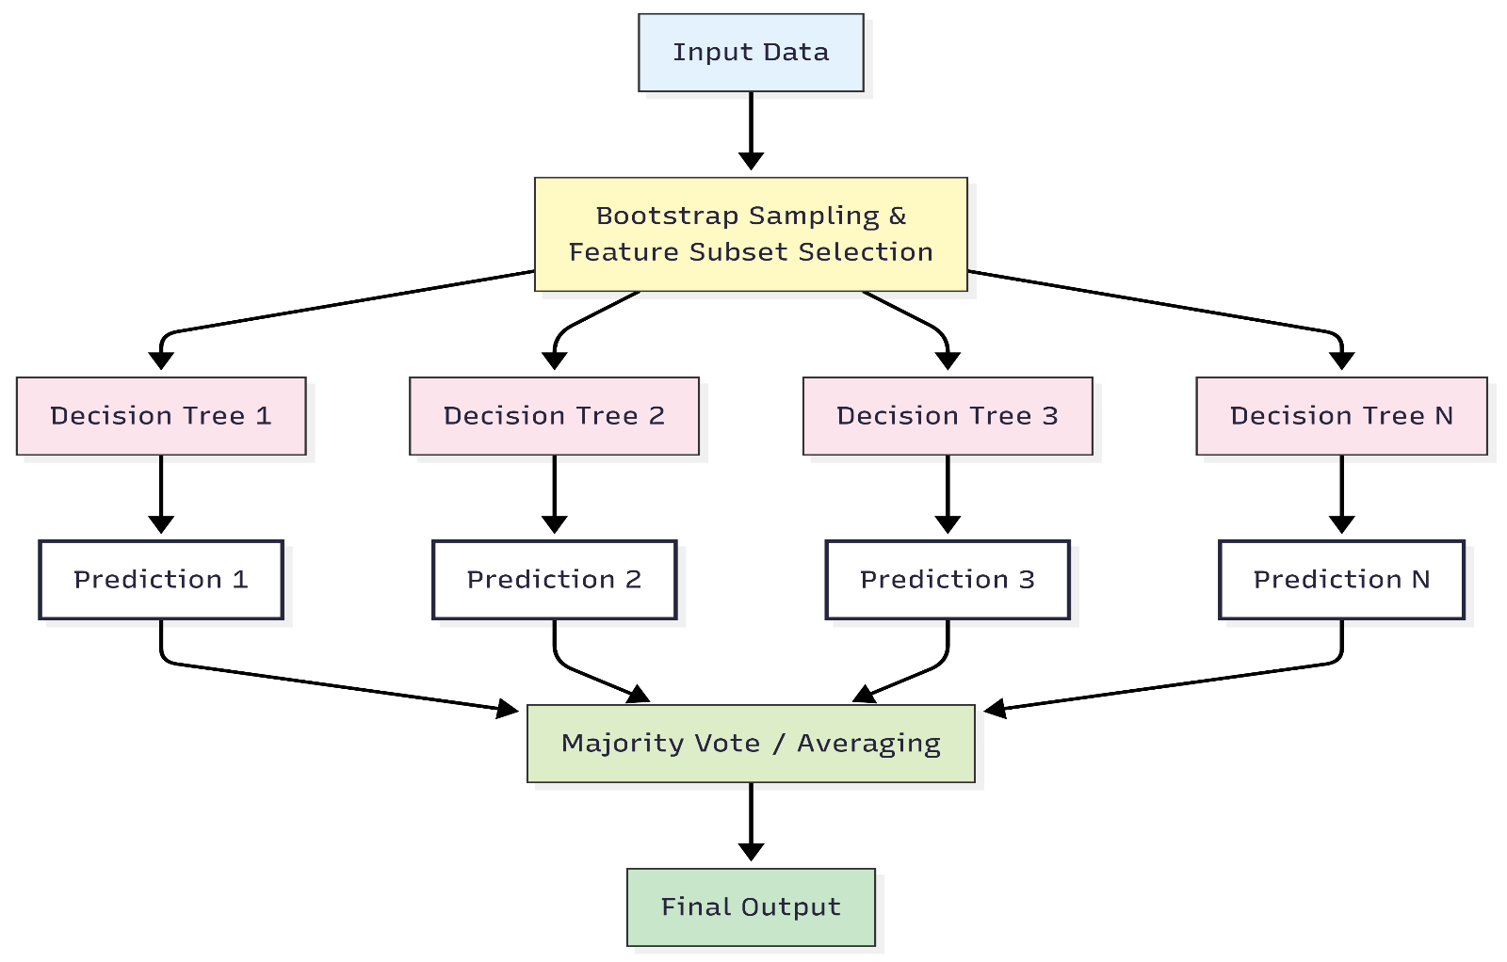
Fig2 . Architecture of Random Forest Algorithm

4.2 Logistic regression
Logistic regression is a fundamental classification algorithm used to estimate the probability that a given input belongs to a particular class. The model architecture begins with a set of input features $\left(x_{1},x_{2},…x_{n}\right)$which are linearly combined with learned weights $(w1,w2,…,wn)$ and a bias term $w_{0}$​. This forms the linear equation:
$z= w_{0}+ w_{1}x_{1}+ w_{2}x_{2}+…+ w_{n}x_{n}$
The resulting linear output z is passed through the sigmoid activation functions, defined as:
$Sigmoid\left(z\right)= \frac{1}{1+ e^{-z}}$
This transformation maps the value of z into a probability between 0 and 1, representing the likelihood that the input belongs to the positive class. Finally, a threshold decision rule is applied: if the probability is greater than or equal to 0.5, the model predicts class 1 (Yes); otherwise, it predicts class 0 (No). Owing to its simplicity, interpretability, and efficiency, logistic regression remains one of the most widely used algorithms for binary classification tasks.
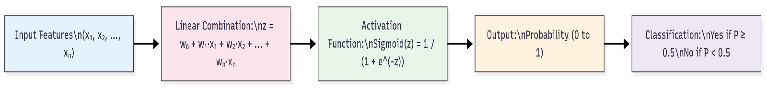
Fig3 . Architecture of Logistic Regression Algorithm

4.3 Support Vector Machine
The architecture of a Support Vector Machine (SVM) classifier begins with a set of input features (x1,x2,…,xn), which represent the characteristics of the data samples. Depending on the separability of the data, an optional kernel transformation (such as linear, polynomial, or radial basis function (RBF)) may be applied to project the data into a higher-dimensional space where linear separation becomes feasible. The model then determines an optimal hyperplane that separates the classes by maximizing the margin — the distance between the hyperplane and the nearest data points of each class. These nearest data points, known as support vectors, play a critical role as they directly define the position and orientation of the hyperplane. Once the optimal hyperplane is established, a decision function is employed: $f\left(x\right)=sign(w*x+b)$
This function classifies new inputs based on which side of the hyperplane they fall on. The final output is a binary class label (typically class 1 or class 2), determined by the sign of the decision function. This margin-based learning approach makes SVMs highly effective classifiers, particularly in high-dimensional spaces and cases with complex decision boundaries.
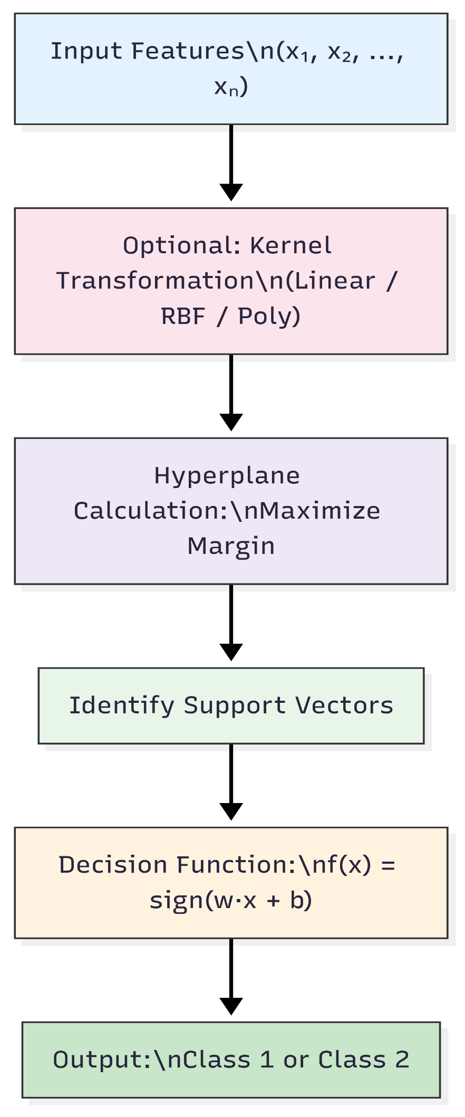
Fig4 . Architecture of Support Vector Machine Algorithm

4.4 CatBoost.
CatBoost (Categorical Boosting) is a high-performance, open-source gradient boosting library developed by Yandex, specifically optimized for handling categorical features and reducing overfitting. Its core architecture is based on gradient boosting over oblivious decision trees, also known as symmetric trees, where each level uses the same split condition across all nodes — making the model more efficient and faster at inference time. Unlike traditional GBDT algorithms, CatBoost introduces a powerful ordered boosting technique to prevent target leakage during training, especially for small datasets. It also applies ordered statistics to convert categorical features into numerical representations via target encoding, without introducing prediction shift. Additionally, CatBoost uses approximate greedy algorithms and GPU acceleration to improve speed and scalability. Altogether, CatBoost’s architecture is designed to maximize predictive performance while minimizing preprocessing and hyperparameter tuning, making it robust for both tabular and complex data applications.
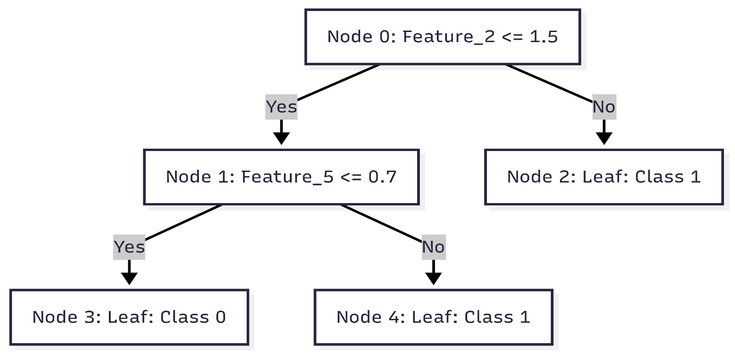
Fig5 . Architecture of Catboost Algorithm

4.5 LightGBM

LightGBM (Light Gradient Boosting Machine) is a fast, efficient gradient boosting framework developed by Microsoft, designed for large-scale and high-performance machine learning tasks. Unlike traditional GBDT implementations that grow trees level-wise, LightGBM uses a leaf-wise tree growth strategy, where it always expands the leaf with the maximum potential to reduce loss. This leads to deeper trees, better accuracy, and faster convergence, though it may require careful regularization to prevent overfitting. Another key innovation in its architecture is histogram-based feature binning, which discretizes continuous values into fixed bins, significantly reducing memory usage and computation time. LightGBM also supports parallel learning, categorical feature handling, and GPU acceleration, making it highly scalable and suitable for big data scenarios. Overall, LightGBM’s architecture is optimized for both speed and accuracy, making it a popular choice in real-world, high-performance machine learning systems.
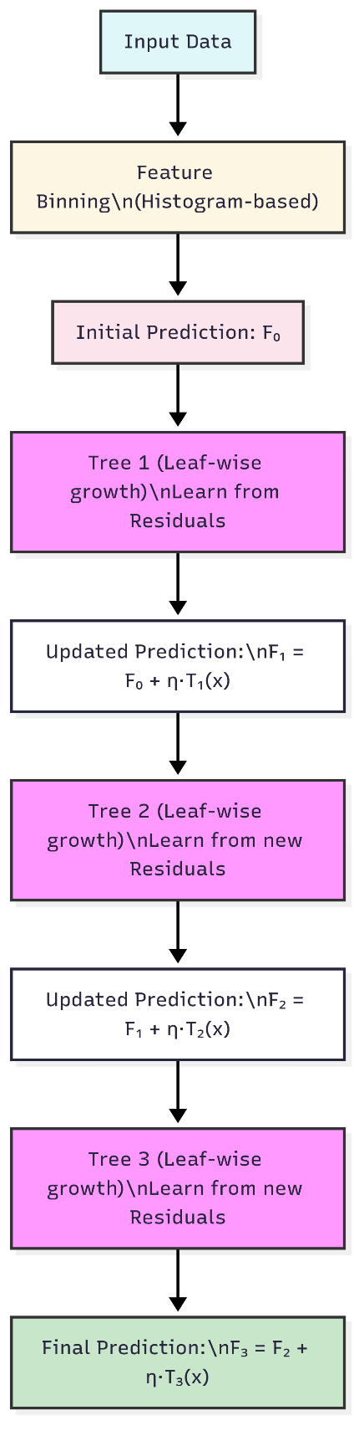
Fig6 Architecture of Light GBM Algorithm

4.6 XGBoost
The architecture of XGBoost (Extreme Gradient Boosting) is based on a sequential ensemble of decision trees designed to optimize both performance and speed. It begins with the input data, from which an initial prediction $F_{0}$ is made, often the mean of the target values in regression tasks. The first decision tree is trained to minimize the loss function using the second-order gradient (Hessian) information, capturing both the slope and curvature of the loss. This results in an update to the model: $F_{1}= F_{0}+η⋅ T_{2}(x)$
where η is the learning rate. The second tree is then trained to fit the residuals of the first tree, again using second-order gradients, and the model is updated to:
$F_{2}= F_{1}+ η ⋅ T_{2}\left(x\right)$
The process continues with subsequent trees like Tree 3, which introduces regularized split selection to reduce overfitting by penalizing overly complex trees. After a number of boosting rounds, the model reaches the final output:
$F_{M }= F_{M-1}+ η ⋅ T_{m}(x)$
This architecture makes XGBoost highly accurate, fast, and scalable, with built-in support for regularization, missing values, and parallel computation.

Fig7 Architecture of XGboost Algorithm

4.7 Gradient Boosting

Gradient Boosting is an ensemble machine learning technique that builds a strong predictive model by combining multiple weak learners, typically decision trees, in a sequential manner. The architecture begins with an initial prediction (like the mean for regression), and each subsequent model is trained to minimize the residual errors (gradients of the loss function) of the previous model. At each step, the new learner fits to the gradient of the loss with respect to the current prediction, gradually improving accuracy. The final output is a weighted sum of all learners, typically scaled by a learning rate (η) to control the contribution of each model. Gradient Boosting allows the use of custom loss functions, supports regularization, and is highly effective for both regression and classification tasks. The modular architecture enables advanced implementations like XGBoost, LightGBM, and CatBoost, which optimize different parts of this pipeline for speed, regularization, and scalability.
Fig8 Architecture of Gradient Boosting Algorithm

5. Results, Analysis, and Comparison
This section presents the classification outcomes of several machine learning models trained on multimodal physiological signals—Photoplethysmogram (PPG), Heart Rate Variability (HRV), and Blood Pressure (BP)—to identify cardiovascular risk categories in a non-invasive manner. The study addresses a multiclass classification problem with five target classes: High Cardiovascular Risk, Hypertensive, Hypotensive, Low HRV, and Normotensive.
To evaluate model performance, we employed 5-fold cross-validation, ensuring robustness and generalizability of the results. The classifiers assessed include Random Forest, Logistic Regression, Support Vector Machine (SVM), and CatBoost, along with additional gradient boosting models such as XGBoost and LightGBM for benchmarking. Evaluation was based on standard classification metrics—accuracy, precision, recall, F1-score, and log loss—calculated over a balanced test set comprising 528 instances.
The primary objective of this study is to enhance non-invasive blood pressure monitoring through multisignal fusion and comparative model analysis, highlighting the potential of AI-powered techniques in preventive cardiovascular health diagnostics.
Dataset overview
The dataset comprised 1305 labeled instances with 56 features each, categorized into five classes: Normotensive, Hypertensive, Hypotensive, High Cardiovascular Risk, and Low HRV. SMOTE was employed to mitigate class imbalance. Feature scaling and normalization were applied prior to model training.
Model-wise Performance Metrics.
The overall training and testing performance of each model in terms of accuracy and loss is summarized in this table.
Table 3 Training and testing performance of each model.
Model | Train Accuracy | Test Accuracy | Train Loss | Test Loss
Random Forest | 0.9834 | 0.9792 | 0.1227 | 0.1445
Logistic Regression | 0.9309 | 0.8996 | 0.2190 | 0.2324
KNN | 0.9503 | 0.9242 | 0.1175 | 0.1760
SVM | 0.9921 | 0.9811 | 0.0032 | 0.0342
CatBoost | 0.9942 | 0.9867 | 4.6045 | 0.0794
XGBoost | 0.9893 | 0.9886 | 0.0017 | 0.0431
LightGBM | 0.9978 | 0.9924 | 0.0026 | 0.0465

summarizes the precision, recall, and F1-score of each model using macro and weighted averages over all five cardiovascular risk classes.
Table 4 summarizes the precision, recall, and F1-score of each model.
Model | Precision (Macro) | Recall (Macro) | F1-score (Macro) | Precision (Weighted) | Recall (Weighted) | F1-score (Weighted)
Logistic Regression | 0.98 | 0.98 | 0.98 | 0.98 | 0.98 | 0.98
SVM | 0.89 | 0.90 | 0.89 | 0.90 | 0.90 | 0.90
CatBoost | 0.92 | 0.92 | 0.92 | 0.93 | 0.92 | 0.92
LightGBM | 0.98 | 0.98 | 0.98 | 0.98 | 0.98 | 0.98
XGBoost | 0.98 | 0.99 | 0.99 | 0.99 | 0.99 | 0.99
Gradient Boosting | 0.99 | 0.99 | 0.99 | 0.99 | 0.99 | 0.99

The performance of all six machine learning models was evaluated on a multiclass classification task consisting of five cardiovascular risk categories. Table 1 shows the overall training and testing accuracy and loss. Table 2 presents the macro and weighted average values for precision, recall, and F1-score. The models LightGBM and XGBoost achieved the highest overall performance with minimal loss, while Logistic Regression showed comparatively lower results due to its linear nature.
Table 5. Visualization of Model Performance Metrics and Evaluation Plots across Multiple Classifiers
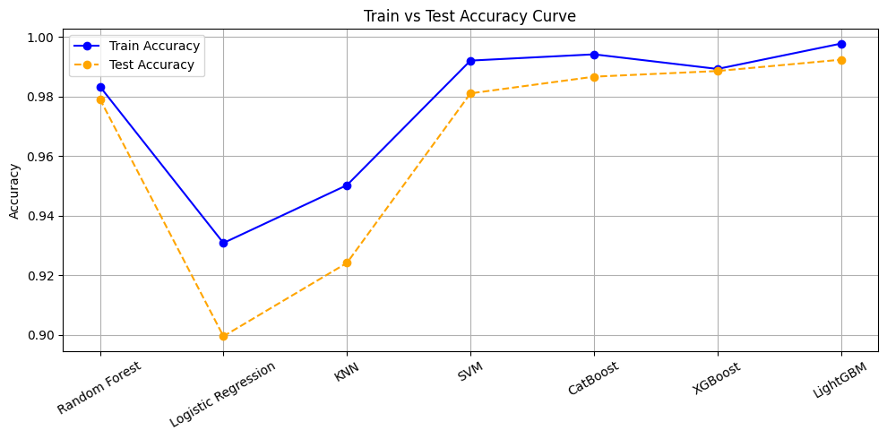  A  A | 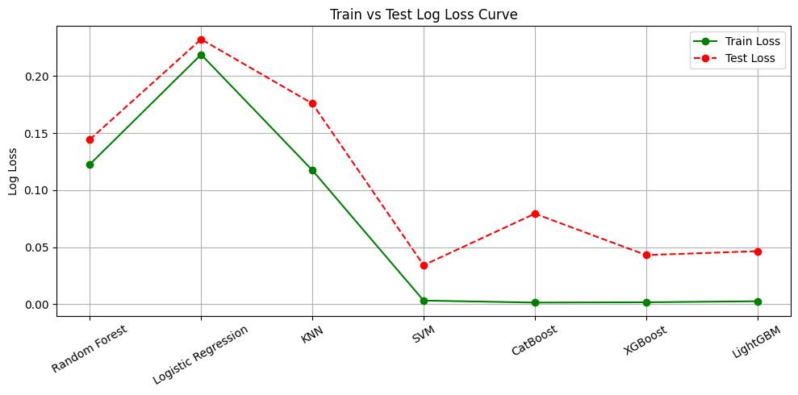  B  B
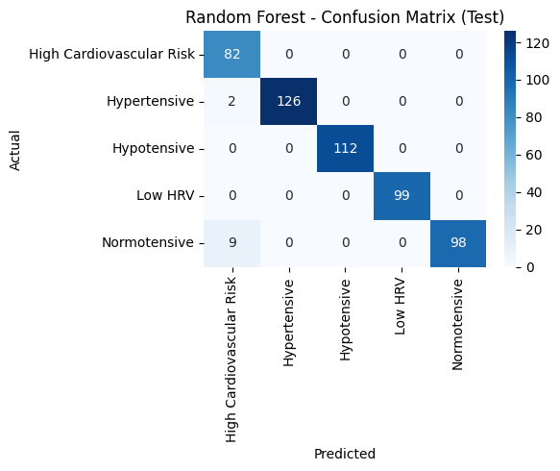  C  C | 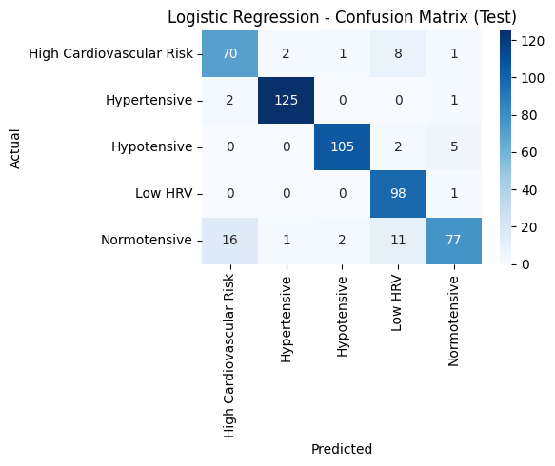  D
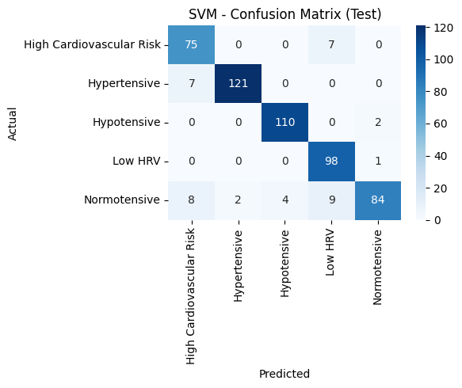  E  E | 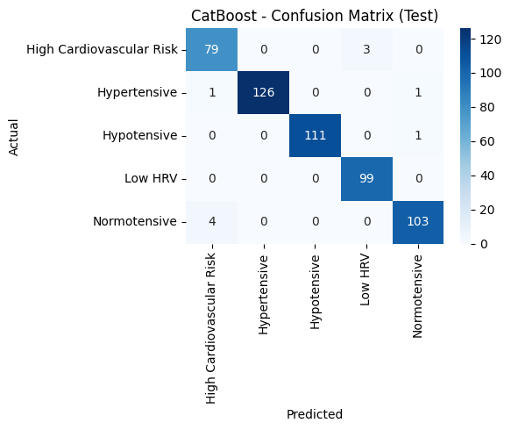  F  F

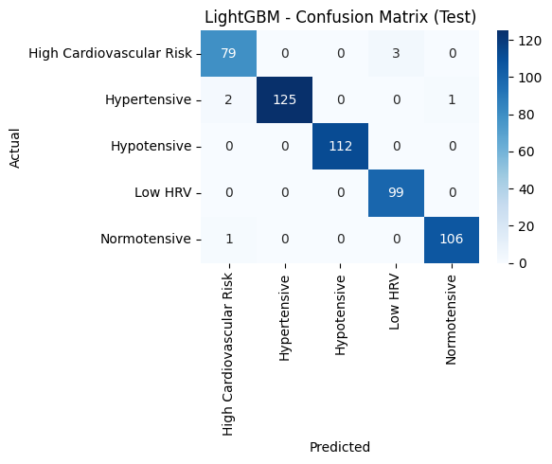  G  G | 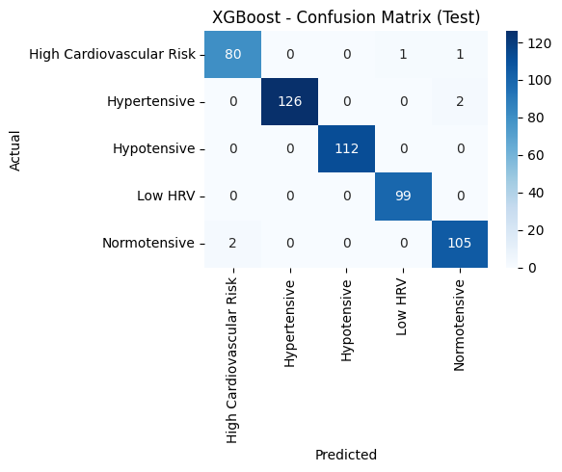  H  H
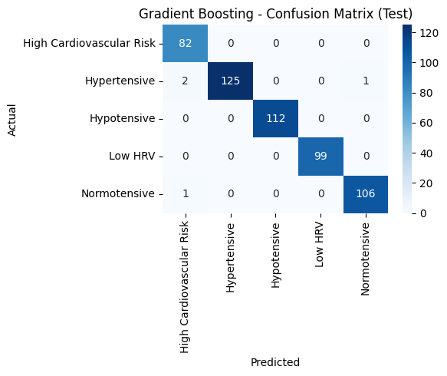  I | 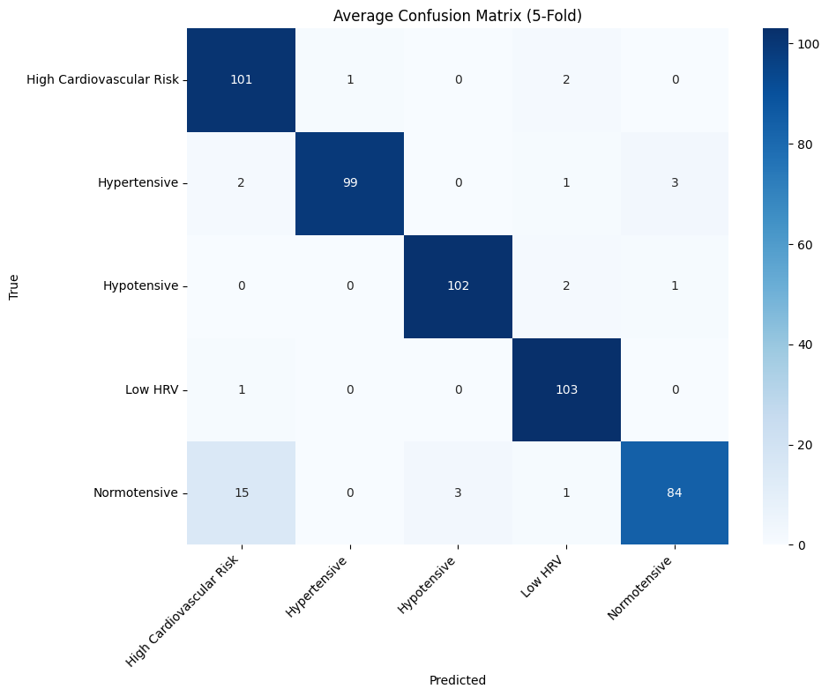  J
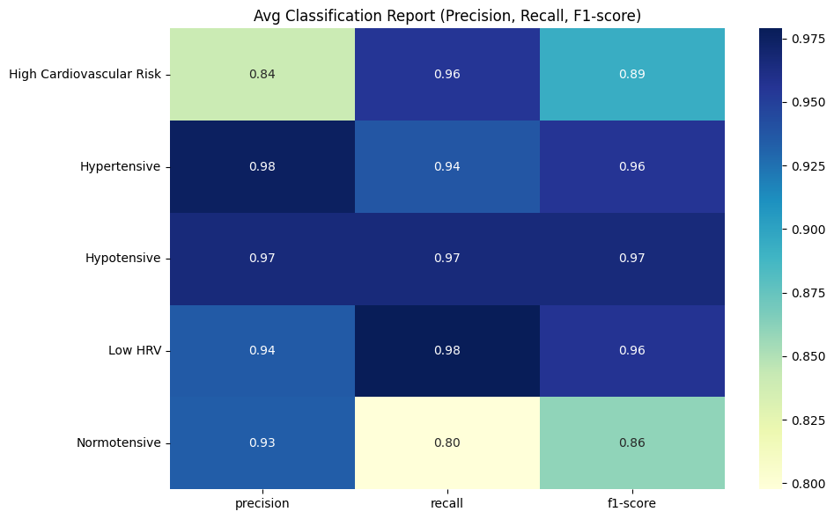  K  K | 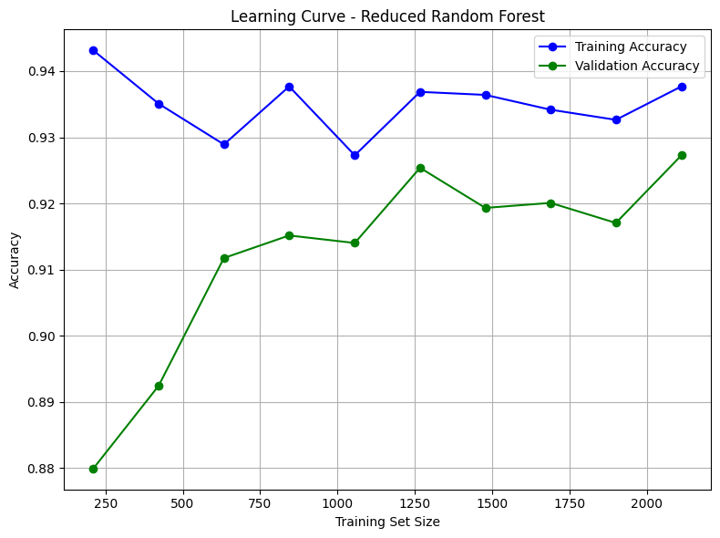  L  L
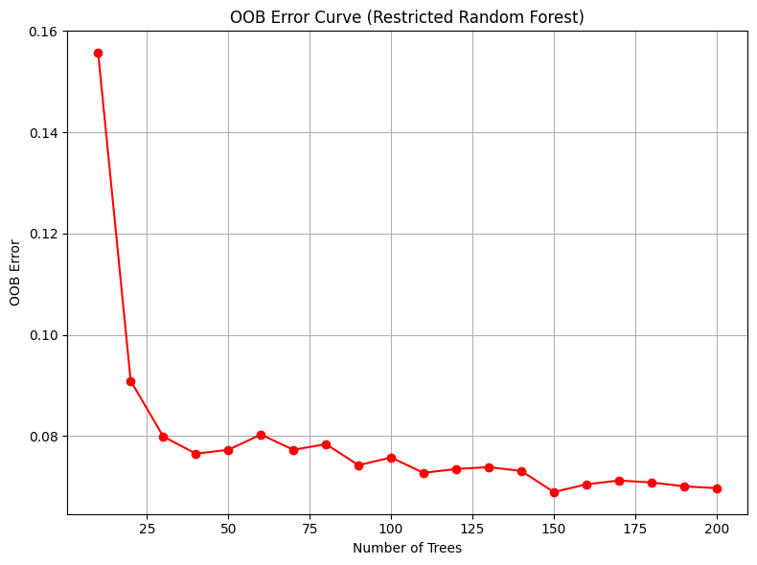
M
M

Table 5 presents a comprehensive set of evaluation plots and metrics for various classification models used in the study. Subfigure (A) displays the Train vs. Test Accuracy curve, while (B) illustrates the Train vs. Test Log Loss curve. Subfigures (C) to (I) show the confusion matrices for different classifiers tested on the test dataset, including Random Forest (C), Logistic Regression (D), Support Vector Machine (E), CatBoost (F), LightGBM (G), XGBoost (H), and Gradient Boosting (I). Subfigure (J) presents the average confusion matrix derived from 5-fold cross-validation, and (K) shows the average classification report highlighting precision, recall, and F1-score across all folds. Subfigure (L) represents the learning curve for the reduced Random Forest model, and (M) depicts the Out-of-Bag (OOB) error curve for the restricted Random Forest. These visualizations collectively provide a detailed comparison of model performance and generalization capability.
Hardware Accelerator Deployment
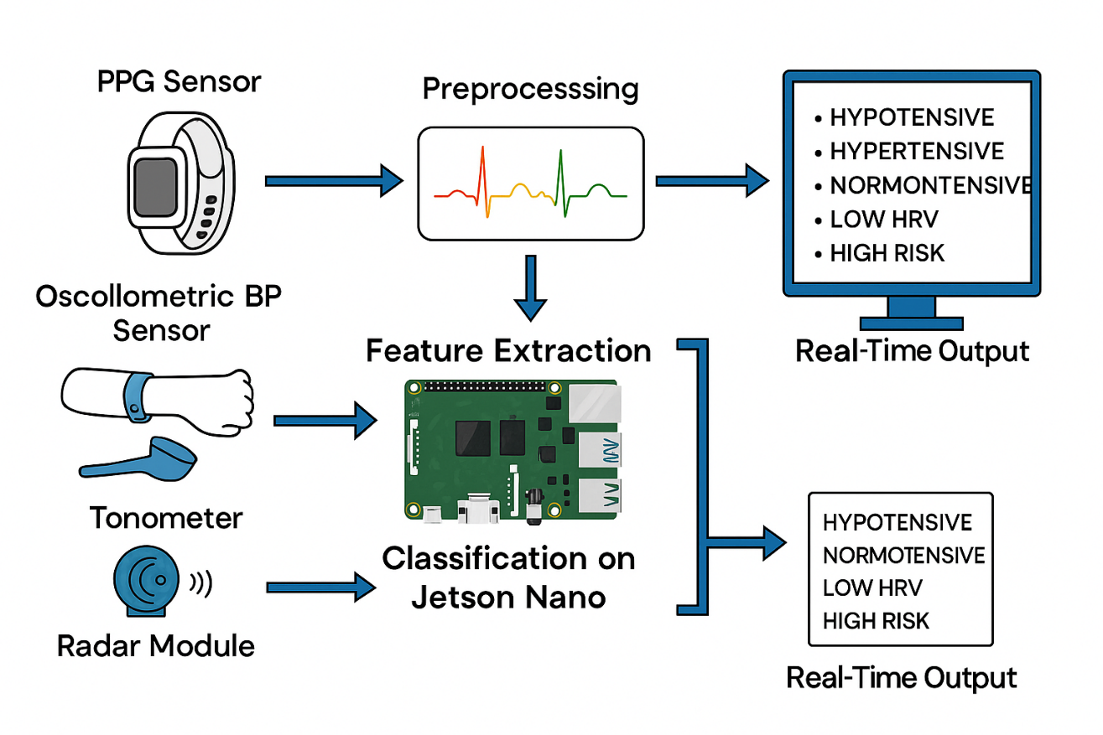
To evaluate the real-world performance of the trained machine learning model, a Random Forest Classifier was deployed on the NVIDIA Jetson Nano. This edge AI device was selected due to its low power consumption and built-in GPU capabilities, which make it well-suited for portable and real-time health monitoring applications.
Figure 9. System Architecture of Multimodal Signal Fusion and HRV Analysis for Blood Pressure Monitoring on Jetson Nano
The deployment process involved saving the trained model in joblib format and loading it on the Jetson Nano. A realistic synthetic dataset was used as input to simulate real-time predictions. The model was executed using Python, and system resource usage was monitored during the entire inference process.
The deployed model was able to classify cardiovascular risk categories such as Hypertensive, Normotensive, Low HRV, and High Cardiovascular Risk. For each prediction, the model also generated class-wise probability scores, helping to measure prediction confidence[33].
The performance of the model on Jetson Nano was evaluated using key metrics including inference time, preprocessing time, model size, CPU and RAM usage. The results are summarized below.
Table 6: Model Runtime Statistics
Metric | Value
Predicted Class (example) | Hypertensive
Preprocessing Time | 0.1697 seconds
Confidence (example) | 0.9500
Model Size | 2.02 MB
Preprocessing Time | 169.7 ms
Average Inference Time | 97.6 ms
Inference Time | 0.0976 seconds
Average CPU Usage | 28.80%
Average RAM Usage | 167.78 MB
Peak Program Memory Usage | Not recorded
Estimated Model FLOPs | Not applicable
CPU Temperature | Not recorded
Power Mode | Default
Operating System | Linux (Ubuntu-based JetPack)
CPU | aarch64
Cores | 4
RAM Total | 3955.96 MB
These results demonstrate that the Jetson Nano is capable of handling the trained model efficiently in real-time with minimal latency and low resource consumption. This makes it a suitable choice for embedded AI systems in portable diagnostic devices.
Table 7: Model Predictions with Confidence Scores for First 10 Samples
Sample | Predicted Class | High CV Risk | Hypertensive | Hypotensive | Low HRV | Normotensive
1 | Hypertensive | 0.0000 | 0.9500 | 0.0000 | 0.0500 | 0.0000
2 | Hypertensive | 0.0100 | 0.8200 | 0.0000 | 0.1300 | 0.0400
3 | Hypertensive | 0.0000 | 0.9400 | 0.0100 | 0.0300 | 0.0200
4 | Normotensive | 0.1700 | 0.3300 | 0.0300 | 0.0500 | 0.4200
5 | Hypertensive | 0.2700 | 0.6100 | 0.0200 | 0.0000 | 0.1000
6 | High Cardiovascular Risk | 0.4600 | 0.2600 | 0.0000 | 0.0700 | 0.2100
7 | Hypertensive | 0.0200 | 0.8100 | 0.0000 | 0.1300 | 0.0400
8 | Hypertensive | 0.0900 | 0.8500 | 0.0000 | 0.0000 | 0.0600
9 | Hypertensive | 0.0200 | 0.9400 | 0.0000 | 0.0200 | 0.0200
10 | Hypertensive | 0.0000 | 0.9400 | 0.0000 | 0.0600 | 0.0000

The table below summarizes the model’s classification results along with associated confidence scores across multiple cardiovascular-related conditions. It demonstrates the model's ability to distinguish between health states such as hypertensive, normotensive, and high cardiovascular risk with varying levels of certainty. These predictions offer valuable insights for evaluating the reliability and confidence of the model’s output.
5. Discussion
Whereas our research illustrates robust evidence for cuffless blood pressure and cardiovascular risk tracking through multimodal fusion of signals and edge-based artificial intelligence, there remain a few significant gaps that need to be filled. Firstly, the dataset with which we worked, while accurately balanced and selected, is moderate in scale and perhaps does not entirely represent the full range of real-world patient heterogeneity—particularly given that many of our recordings were taken under relatively controlled conditions. This controlled environment was needed for consistency, but it also means we couldn't test how the system would perform the full gamut of physical activities, everyday movement, or varying lighting and noise that humans have in their everyday lives. Moreover, participants' demographic range was restricted; parameters such as age, ethnicity, and particular health history could affect both measurements and model behavior in a manner that our existing configuration might not capture. In combination, these constraints imply that though our findings are encouraging, more needs to be done before this technique can be confidently translated into actual clinical practice or used on a large scale in consumer wearables.
Looking ahead, our priorities become clear. Increasing the dataset is paramount—not just in volume, but in the variety of individuals and real-world situations included. We want to recruit participants of different ages, health levels, and activity levels, and to collect data in more unstructured, everyday settings. This change should cause our models to become even more resilient and applicable. Concurrently, we are investigating deeper, more adaptive machine learning approaches, such as sophisticated deep learning algorithms and federated learning, that would allow wearable devices to enhance algorithms on their own locally without divulging user information. In addressing these areas, we think future releases of our system will provide both higher accuracy and more reliability, the groundwork for effectively practical, easy-to-use cardiovascular monitoring in everyday life and the clinic.
6. Conclusion
To sum up, this study builds a practical and scalable system for blood pressure monitoring and heart risk detection. By combining signals like PPG data, it improves accuracy compared to using a single signal type. Among all models tested, LightGBM and XGBoost stood out with top performance. The system also works well on edge devices, proving it's possible to do fast, accurate heart health checks without a lab. It can detect various BP levels and heart risks efficiently, with low power use and easy integration into wearables—making it ideal for everyday and clinical use.
While this study shows promising results, it has some limitations—like a relatively small sample size (1,305 people), limited diversity among participants, and testing in controlled settings that don’t fully reflect real-life situations. Going forward, the plan is to include more varied data, track patients over time, and consider real-world factors like movement and noise. There’s also potential to explore deep learning and privacy-friendly techniques like federated learning directly on wearable devices. Overall, this work lays a strong foundation for smarter, real-time heart health monitoring in everyday life.

